EMPOWERMENT THROUGH COMMUNICATION PROGRAM
The Augmentative and Alternative Communication (AAC) Team offers the Empowerment Through Communication (ETC) Program once or twice yearly, depending upon the demand. Clients who already own their communication devices and want to become more proficient with using them to meet their daily communication needs are eligible to attend this two-week intensive program.
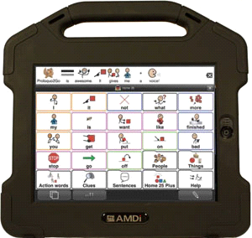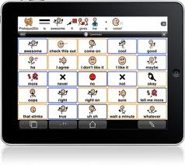
Program Goals | Requirements –  Participants Must: | Communication and Empowerment Activities
- facilitate communicative competence through intensive group communication activities  - provide empowerment training to broaden participants’ horizons  - encourage progress toward setting vocational and independent living goals | - own a functioning AAC device  - be able to commit to ten days  - be interested in becoming more integrated into the community  - be motivated to improve communication skills  - be ready to have fun and try new things | - conversation skills  - interviewing  - storytelling  - making speeches  - making phone calls  - asking questions of presenters  - initiating conversation within the community  - learning programming skills  - potentially learning computer access or computer components of the device
Contact Information  Web Site: wwrc.virginia.gov  Email: AACInfo@wwrc.virginia.gov  Phone: 800-345-9972, Ext. 7086  540-332-7086  TTY: 800-811-7893 | 