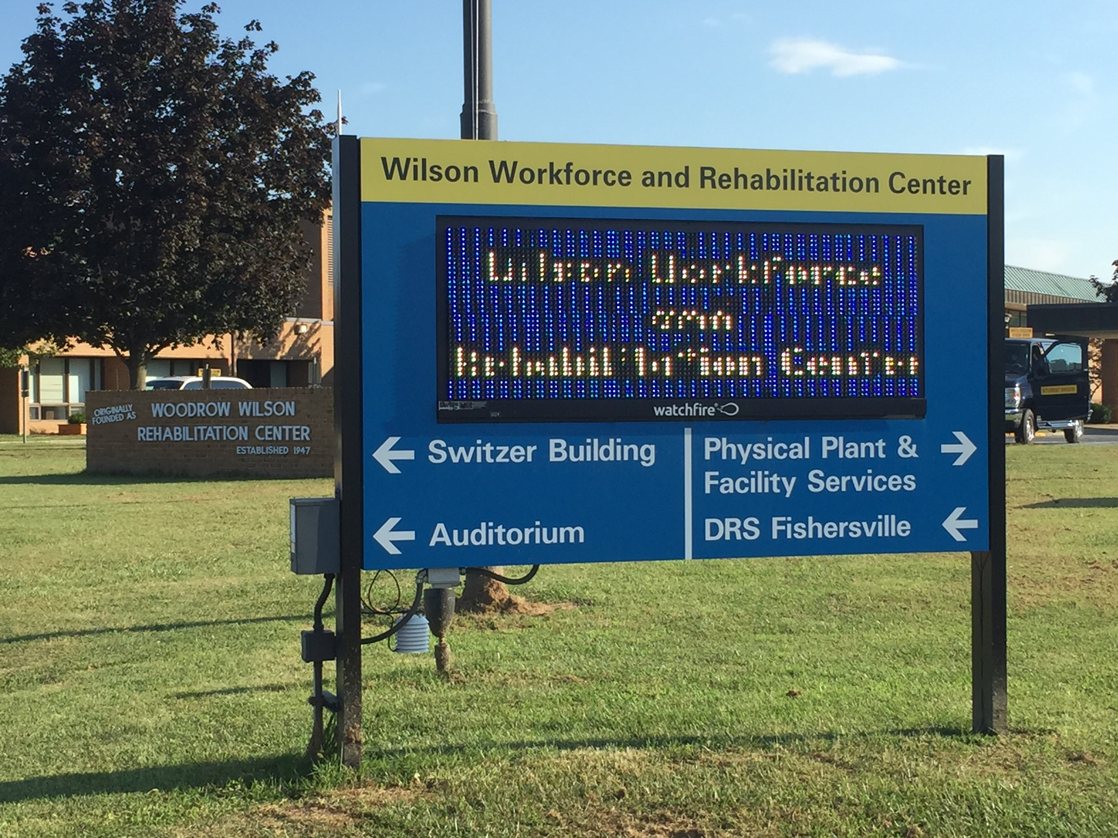

**Wilson Workforce and Rehabilitation Center**

**Campus Fire Safety Report**



October 2018

The Office of Safety and Risk Management

Chip Stratton

**This page intentionally left blank.**

**Campus Fire Safety Report**

TABLE OF CONTENTS

Executive Summary Page 4

WWRC Fire Systems Page 4

 Fire Safety - Tampering Page 5

 Dorm Policies Page 5

 Fire Drills Page 5

 Campus Fire Log Page 6

 Emergency Preparedness Drills Page 7

 Training Page 7

 Emergency Alert System Page 8

 Improvements Page 9

Future Challenges Page 10

**Executive Summary**

The mission of the WWRC Safety and Risk Management Office is to promote the safety and emergency preparedness of students, staff, and visitors to the Wilson Workforce and Rehabilitation Center.

The Campus Fire Safety Right-to-Know Act is an amendment to the Higher Education Opportunity Act. This amendment serves to increase campus fire safety awareness across the nation, providing students and their families with the fire safety records of colleges/universities. Signed into law by President George W. Bush on August 14, 2008, this amendment requires post-secondary institutions to publicly display fire safety information and statistics, much as they already do with other safety statistics, such as campus theft and assault. This information provides prospective and current students of the policies, concerns, and fire safety conditions that are present at the institution in which they have applied or are enrolled.

WWRC has developed this report with all the required information for viewing. Please take time to review our statistics and fire safety information. Let us know if you have any questions in regards to fire safety. We can be reached daily at 540-332-7163 to answer any questions.

**WWRC Fire Systems**

Anderson, Carter, Barnett, Watson and Rothrock fire panels are monitored externally by Richmond Alarm Company and internally by the SARA emergency notification system. All other campus buildings are monitored internally by SARA. WWRC PD is alerted via Richmond alarm and/or SARA to the activation of the building alarm systems. Additional fire system information is located in the following table:



**Fire Safety – Tampering**

False alarms, damage, theft, or misuse of fire detection, alarm or extinguishing equipment are punishable under the Code of Virginia and Virginia Statewide Fire Prevention Code as described below:

Code of Virginia - § 18.2-212. Calling or summoning ambulance or fire-fighting apparatus without just cause; maliciously activating fire alarms in public buildings; venue.

A. Any person who without just cause therefore, calls or summons, by telephone or otherwise, any ambulance, or fire-fighting apparatus, or any person who maliciously activates a manual or automatic fire alarm in any building used for public assembly or for other public use, including, but not limited to, schools, theaters, stores, office buildings, shopping centers and malls, coliseums and arenas, regardless of whether fire apparatus responds or not, shall be deemed guilty of a Class 1 misdemeanor.

B. A violation of this section may be prosecuted either in the jurisdiction from which the call or summons was made or in the jurisdiction where the call or summons was received.

Virginia Fire Prevention Code – 901.8. Removal of or tampering with equipment.

It shall be unlawful for any person to remove, tamper with or otherwise disturb any fire hydrant, fire detection and alarm system, fire suppression system, or other fire appliance required by this code except for the purpose of extinguishing fire, training purposes, recharging or making necessary repairs, or when approved by the fire code official.

**Dorm Policies**

All campus buildings are smoke-free. There are designated smoking areas located throughout the Center. These areas are routinely monitored by WWRC staff for compliance and cleanliness.

As part of our fire safety program, WWRC prohibits the following items in dorm rooms: microwaves, irons and electric blankets. We also prohibit incense, candles or open flames. Extension cords are not allowed in dorm rooms; power strips with surge protectors are allowed. If medically necessary, a student may have a heating pad in the room but must it must have an automatic “shut-off” safety switch. Electrical applies such as curling irons and coffee makers, which are allowed in dorm rooms, must be UL rated and have an auto shut off.

**Fire Drills**

Fire Drills are conducted at WWRC to avoid confusion and ensure the evacuation of all occupants during an actual fire. Fire Drills are used to familiarize employees and clients with the audible and visible evacuation signals and the exit routes available to use in the event of a fire or other situations that require immediate evacuation. Primary and alternate routes are established, and all employees and clients should be familiar with multiple routes. Fire Drills are used to evaluate the performance of participants in a fire incident and to gauge the effectiveness of the behaviors used in accordance with the Center’s Emergency Action Plan. 40 fire drill evacuations were conducted during the period of January 1 through Dec 31, 2017. During the same period there were no recorded fires in any of our housing units and a significant reduction in accidental alarm activations. Shown below is information specific to each housing facility:

**Campus Fire Drills Jan-Dec, 2017**

|  |  |  |  |
| --- | --- | --- | --- |
| **BLDG** | **BLDG#** | **# DRILLS** | **EVAC PLANS POSTED** |
| Anderson | 803 | 4 | Yes |
| Barnett | 804 | 12 | Yes |
| Birdsall Hoover/Rothrock | 806 | 12 | Yes |
| Carter Ashley | 801 | 12 | Yes |
| PPS | 708 | 1 | Yes |
| BO/HR/DRS | 701/702/703 | 1 | Yes |
| Switzer | 805 | 8 | Yes |
| Watson | 802 | 2 | Yes |

**Campus Fire Log**

|  |  |  |  |  |  |  |
| --- | --- | --- | --- | --- | --- | --- |
| Date of Incident | Location of Incident | Cause of Fire | Number of Injuries Requiring Medical Treatment | Number of Deaths Related to Fire | Value of Damage | Additional Information |
| 11/17/2017 | Cottage 2 | No fire- Smoke alarm activation. Student burned food | 0 | 0 | 0 | Alarm activated at 8:57AM. All clear issued at 9:05AM |
| 11/17/2017 | Cottage 8 | No fire- Smoke alarm activation. Student burned food | 0 | 0 | 0 | Alarm activated at 8:30PM. All clear issued at 8:35PM |

**Emergency Preparedness Drills**

In addition to the fire drills required by Code, a minimum of four Center wide drills are conducted annually to evaluate staff and student response to emergency events. The drills conducted in 2017 involved Tornado, Earthquake and 2 Active Shooter scenarios. After each Campus-wide drill, we conduct an after action review with representatives from each building and generate a written report. The drills and reviews provide the opportunity for WWRC to make improvements in procedures and processes based on feedback from staff.

**Training**

Staff and students receive training addressing our emergency response and evacuation procedures. The Center’s Emergency Action Plan utilizes colored alerts to initiate the appropriate response in an emergency situation. The following is an excerpt from the EAP:

**RED ALERT = EVACUATE**

**FIRE**

**ACTIVATE ALARM.**

**EVACUATE.** Use fire exits only. Do not use elevators. Take personal items (cell phone, coat, keys, etc.) Wait for head count.

**When you discover a fire:**

Activate alarm and call 332-7266 to report location of fire.

Evacuate and wait for head count. Take coat and purse. Use fire exits only. Do not use elevators.

**When you hear fire alarm or “RED ALERT” announcement:**

Evacuate the building using the nearest exit; close office doors and turn off lights. Take your keys, coat and purse.

Report to designated area for head count for your work unit. If you are responsible for accountability report for your unit, take the reporting form with you to ensure accountability for all staff and to record that all areas (storerooms, restrooms, etc.) have been checked to ensure they have been vacated.

Designated Department representative will report to Command Post Officer.

All staff, clients and visitors must remain in designated area until “ALL CLEAR” or further instruction is provided by Command Post Officer, WWRC PD, WWRC SRM or Emergency Responders.

 In addition, signs are posted throughout the campus giving guidance on response to various alert conditions as well as evacuation maps applicable to either a specific building, floor of a building or, in cases of large buildings; the map is applicable to a particular section or wing of a building.

New staff and students attend orientation programs which include sessions on fire safety. Staff and students are provided telephone numbers on the back of their identification badges for use in reporting fires. One number is our emergency phone system which is manned 24 hours a day/7 days a week by Administrative or Nursing personnel. The other number is for our area’s Emergency Operations Center. In addition, students are advised they may contact any staff member to report a fire or, where available, may pull the fire alarm.

Staff (classified, hourly and contract) attend classroom Safety and Risk Management New Employee Orientation which is conducted by a member of our Safety and Risk Management Unit. Topics covered in this program include:

* + - WWRC’s Emergency Action Plan to include our Emergency Communications System (SARA)
    - Evacuation Procedures
    - Fire Drill Procedures
    - Electrical Safety

Students attend orientation presented by personnel from the Residential Services Division. Topics covered during this orientation include:

* + - WWRC’s Emergency Action Plan to include our Emergency Communications System (SARA)
    - Dorm Evacuation Procedures
    - Fire Drill Procedures
    - Regulations on smoking, cooking, open flames, extension cords, etc., in dorm rooms

Upon completion of the designated orientation program, the staff member or student will sign a form indicating that the topics listed above have been covered. The WWRC Student Handbook also addresses regulations applicable to dorm rooms.

**Emergency Alert System**

WWRC uses an Emergency Alert System, commonly known as SARA (**S**ituation **A**wareness and **R**esponse **A**ssistant), to alert clients, staff, families, visitors, and community partners in the event of an emergency affecting its campus and to provide routine updates regarding the status of the emergency situation.

The Emergency Alert System (SARA) uses a WWRC campus public broadcast system which includes:

* electronic message boards,
* radios,
* speakers,
* strobe lights,
* email and
* phones (cell, land-line, text).

Also, emergency alert messages may be displayed on the WWRC Internet Home Page.

Clients, families, and community partners who wish to be alerted via phone or email during an emergency can request this service by:

* calling WWRC Safety and Risk Management Department: 540-332-7163 or 540-332-7189
* emailing [Safety and Risk Management Department](mailto:SafetyRiskManagementInfo@wwrc.virginia.gov?subject=WWRC%20web%20site%20inquiry) to provide their cell and/or landline phone number or email or cell phone text address.

Emergency contact information may be removed or changed at any time by using the same methods listed above.  Please note that the alert system (SARA) is also used for:

* routine drills and
* system status checks.

By providing personal contact information, staff and clients are alerted during campus-wide drills or alert system testing.

**Improvements**

Anderson Training Building is currently undergoing renovations. Once completed, the building will have an upgraded Honeywell fire alarm panel and be fully sprinklered. Main buildings at WWRC are supported by Honeywell fire safety technology. This system provides a critical advantage for early warning fire detection by visually detecting the presence of fire or smoke at its source, independent of airflow in the area in the earliest stages thereby protecting lives and property.

WWRC has integrated the SARA system with all existing fire panels on campus. This integration allows our PD to be alerted via two-way radio, phone, text and email when any fire panel on campus goes into alarm mode.

WWRC has installed 6 new message boards in several buildings to include 2 boards with integrated horn strobes in the Auto Mechanics Training Shop and Vocational Evaluation Woodworking Shop.

We continue to focus on improving our processes and communications related to the Center’s Emergency Planning, Preparation, Response and Recovery Plan. This plan contains reference documents, procedures and programs related to our Center’s plans for preventing, responding and recovering from emergencies. A modified version of this document (with some sensitive information removed) is available to employees on the global drive under Safety and Risk Management as well as in a Knowledge Center Team Room.

WWRC worked with Augusta County Fire Department, specifically Companies 10 and 11 to complete the annual tour of the campus and fire pre-planning.

**Future Challenges**

Key challenges include:

* Ensuring preparation for a major emergency disaster at WWRC; previous events at campuses around the United States require increased concern that this could occur in the coming years, and the Center must be prepared to ride out the event and promptly recover.
* It is critical that emergency preparedness programs be extended throughout the Agency to ensure adequate fire, life safety, and emergency response in these vital areas.
* As WWRC is a 24/7 campus, there is an ever present challenge to ensure coverage of the myriad of after-hours and weekend activities.